Notes: Create a Jira ticket for this assignment, work on the tasks listed below, and submit the challenge completion document by EOD with clear steps and required evidence (outputs/screenshots).
Git Challenges
- Resolve Merge Conflicts
  - Create a merge conflict intentionally (two users editing the same line).
  - Resolve the conflict and push the changes.
- I have created a file in master branch and added some contains in it then I switched to develop branch and created a file with same name but different contains and after committed both file I a tried to merge both branches then I got merge conflict error then I edited file and did necessary changes add add and committed it so its automatically completed merge with branch.

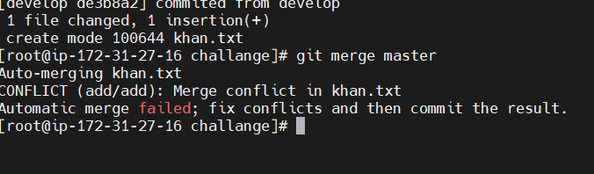
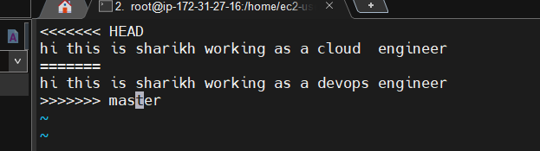
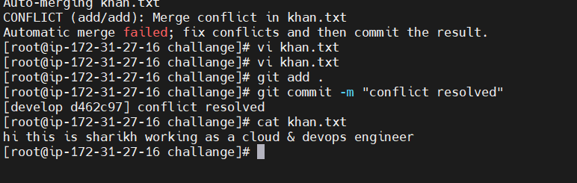
- Recover Deleted Branch
  - Delete a local branch and then recover it using the reflog.
- First I have deleted a branch using ($ git branch -D <branch_name>)
- Then I used command ($git reflog) for checking the local history of commit
- Then I found the latest commit which I switch from a branch to other branch after that I just use below command to recover the deleted branch and switch into it.
- ($ git switch -c <branch_name> <latest commit id>)
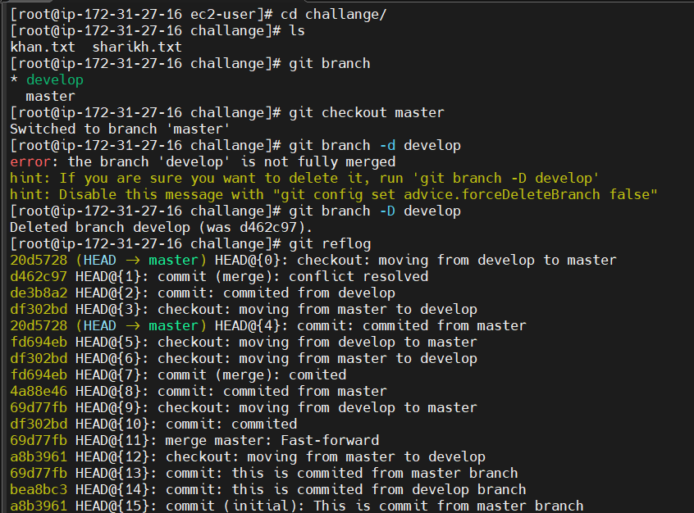
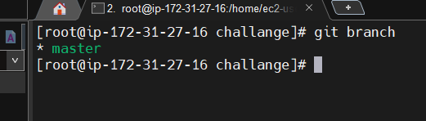
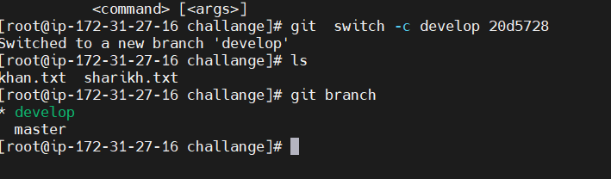

- Undo Wrong Push
  - Push a wrong commit to GitHub, then undo it without losing history.

- I have committed a file and and pushed it to my remote repository using git push command
- Then I have to undo this push so that’s why I checked the commit id of pushing activity using ($ git log --oneline) and I just use below command to revert the commit
- ($ git revert <commit_id>)
- And then I do git push again for sync remote repo and the file I pushed are removed and like reverted.
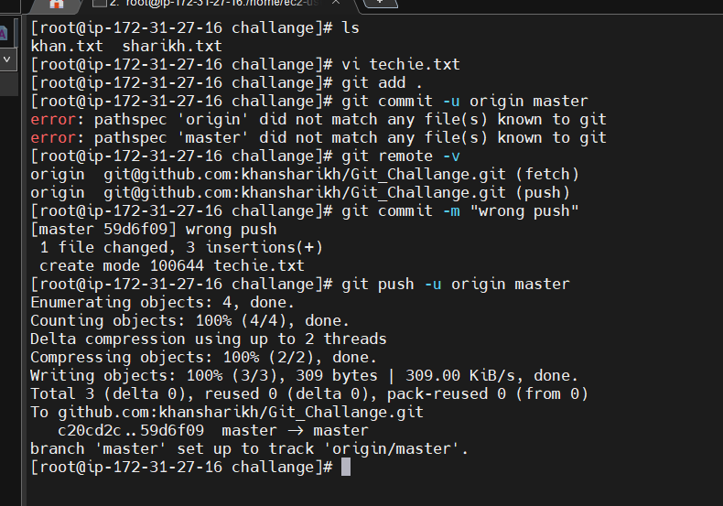
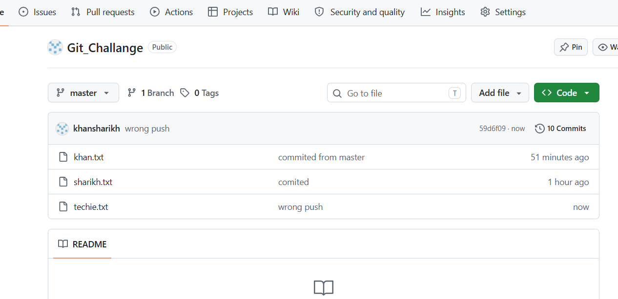
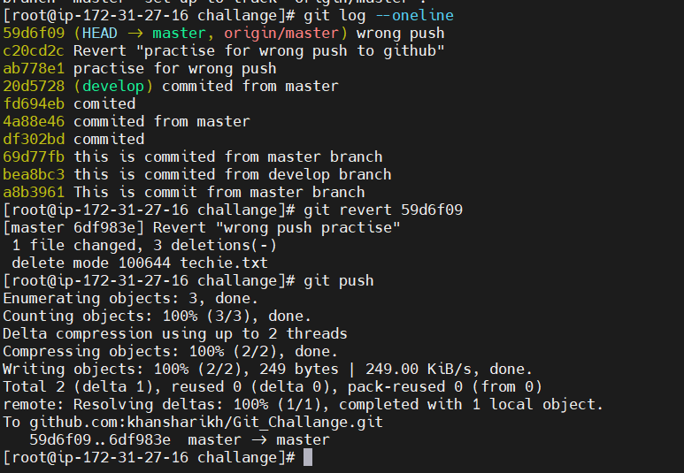
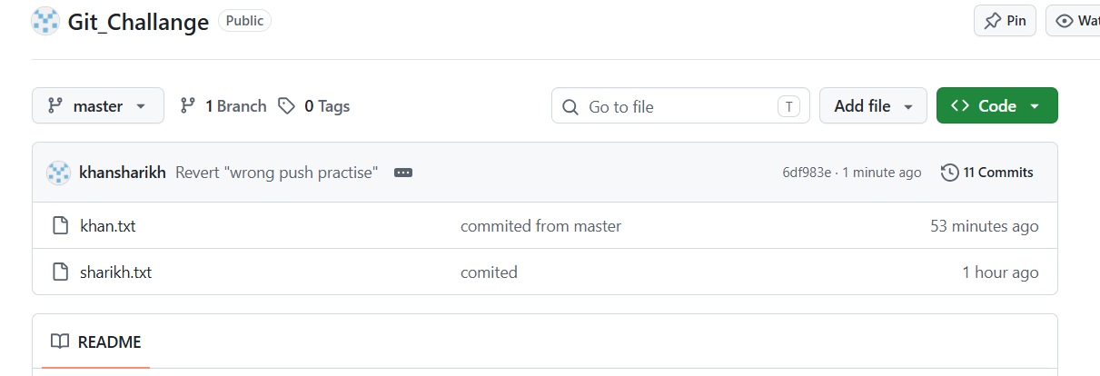

- Amend a Commit
  - Make a commit, then add a missing file to it using git commit --amend.
- I have vreated a file and committed in local repo.
- Then I have one another file added in stagging area now I have amended the last commit using ($ git commit –amend)
- And then the staggin areas file also is committed with that previous commit.

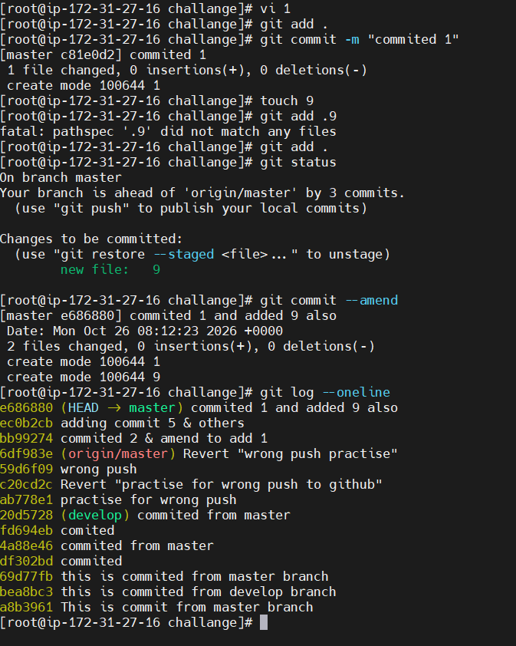

- Cherry-pick a Commit
  - Take a specific commit from one branch and apply it to another branch.
- I have created a 3 files and committed it from develop branch
- I u8sed git log for note of that commit id
- Then I switch to master branch and use that commit id via below command to copy whatever I committed in master branch using cherry-pick.
( $ git cherry-pick <commit_id>
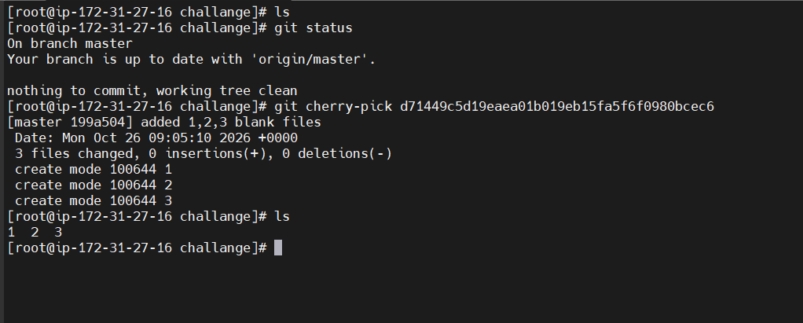

- Interactive Rebase
  - Reorder and squash multiple commits into a single clean commit.
- I have makes three commites with adding 1-1 files each
- Then using ($ git log --oneline) I see the all commits
- After that I used command ( $ git rebase -i HEAD~3) for merging all three commits id in single commit for clean view.
- Then interactive one file will open and I leave fist pick as it is and replace pick with sqash for below two commits line.
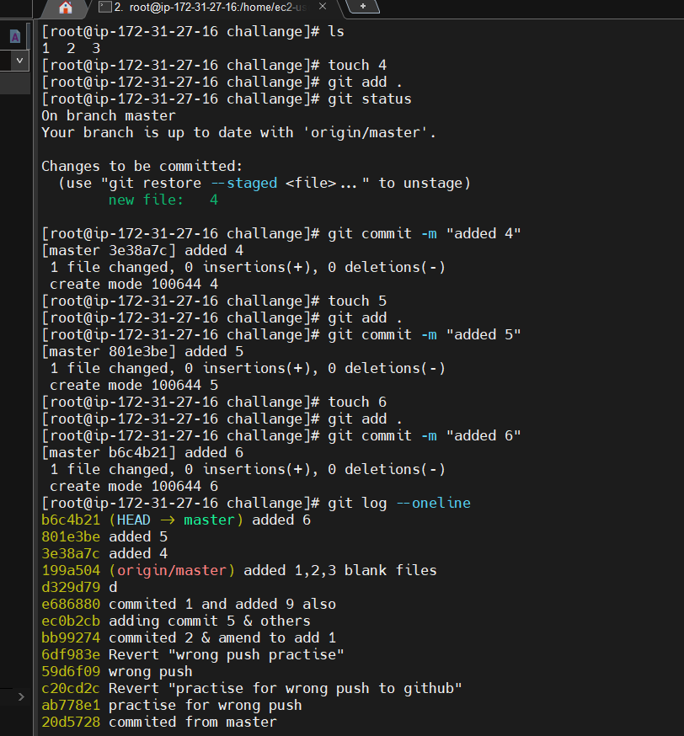
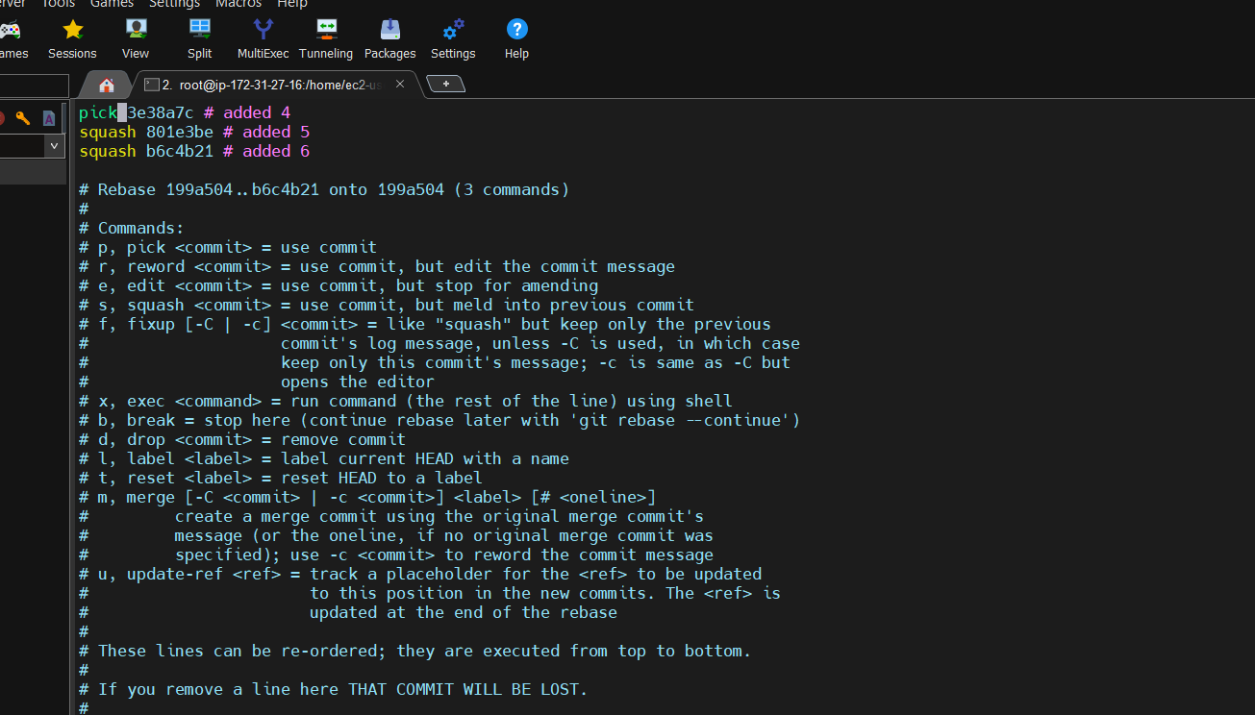
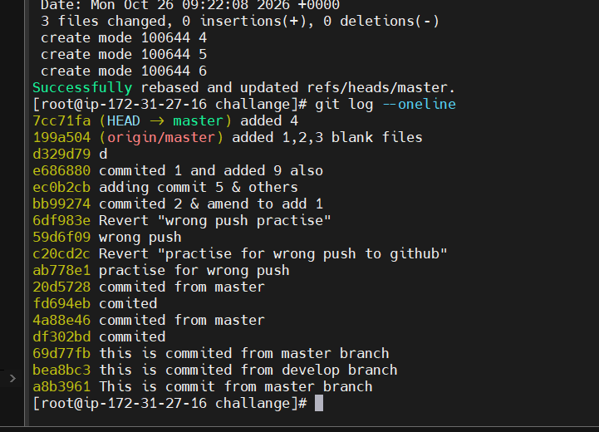
- Tagging & Release
  - Create a version tag (v1.0), push it to GitHub, then delete and restore it.
- I have created version tag using command ($ git tag -a v1.0 -m <message>)
- Version is tag is nothing its just add a zip file with all the committed or with all source code till now and make it v1.0
- Then I pushed that vesion in GitHub using ($ git push origin v1.0)
- I have deleted version from local using ($ git tag -d v1.0)
- And in remote using ($ git push origin –delete v1.0)
- After that for restore I used command
($ git tag -a v1.0 <commit_id> -m <message>)
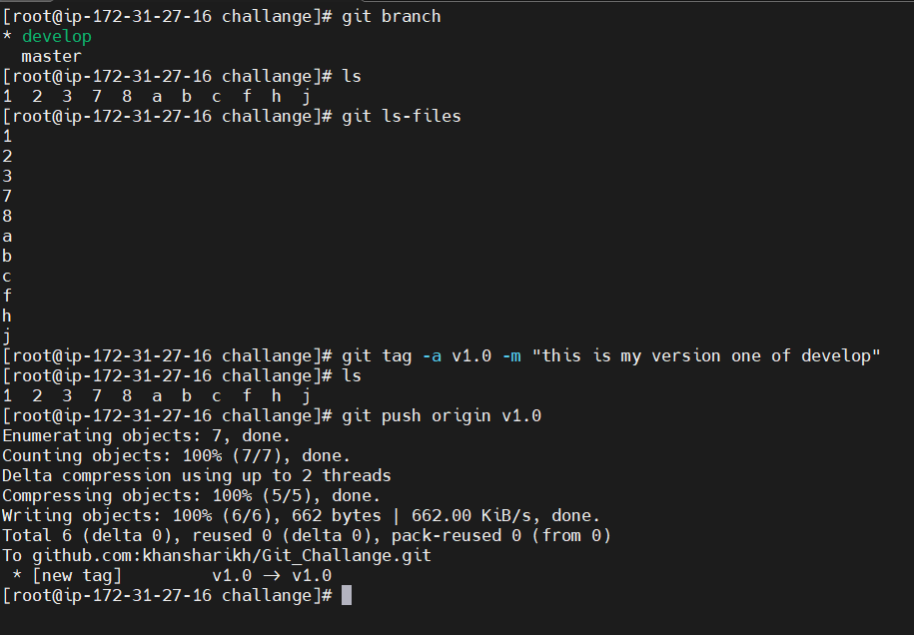
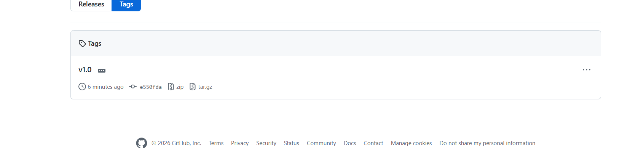
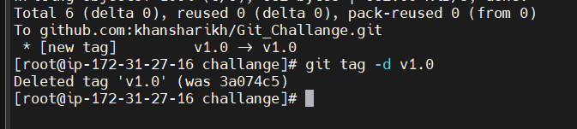
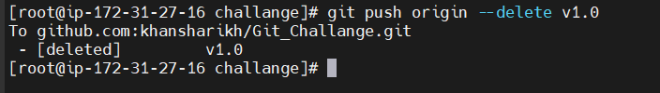
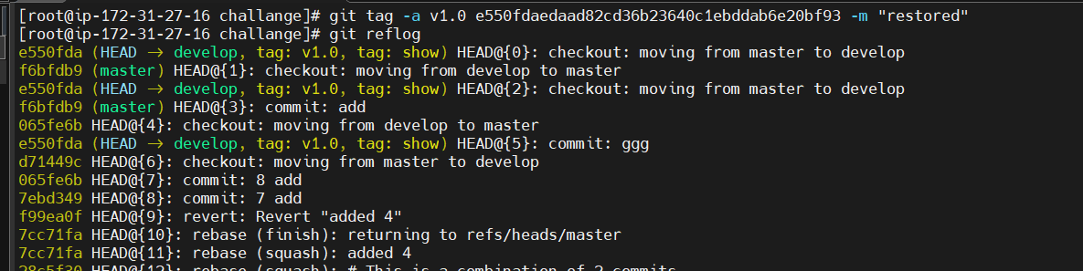
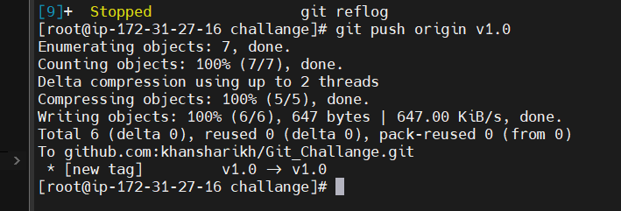

- Clone with Sparse Checkout
  - Clone only a subdirectory of a repo using sparse checkout.
- I have used the below command for cloning a projects only one directory.
($ git clone --no-checkout <_____url_______).
- Then I used the command ($ git sparse-checkout init --cone) for initialize the cloned repo
- And then I used belo command for giving the path of directory what I want to download ($ git sparse-checkout set path/)
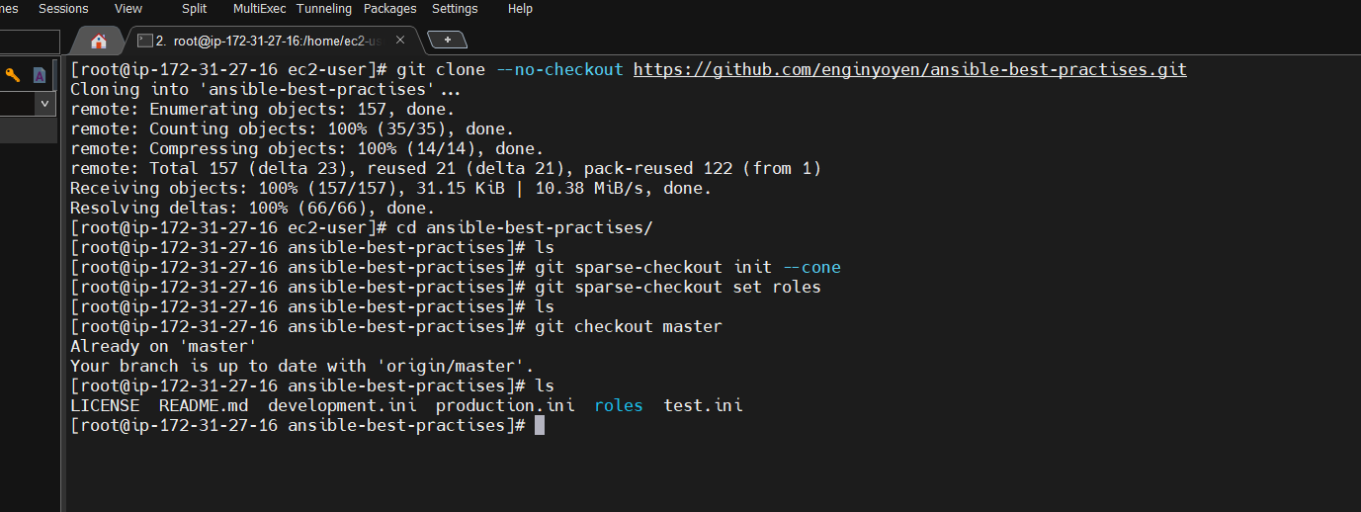

- Reset vs Revert Challenge
  - Demonstrate the difference between git reset --hard and git revert in a repo.
- Reset –hard is for removing that commit from committed also from staging and upstaging area completely removes.
($ git reset --hard <commit_id>)
- revert will remove the,data or work on that and Head towards the new commit and reset will remove the, data or work on that commit and also commit history of that commit and head towards the privous commit.
- ($ git revert <commit_id>)
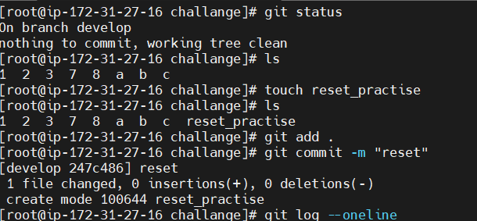

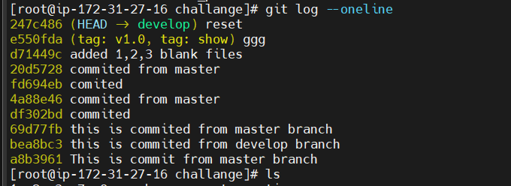
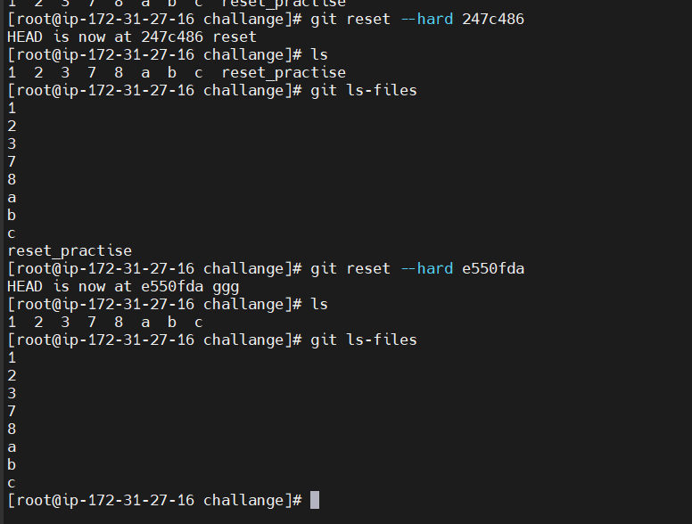
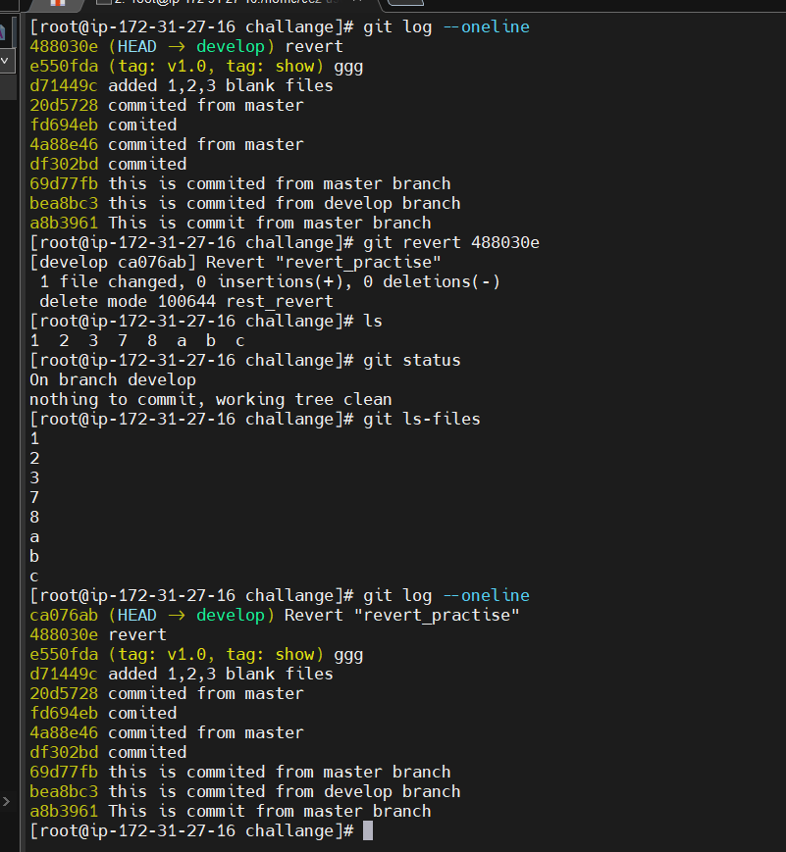

- Detached HEAD Challenge
  - Checkout a specific commit (detached HEAD state) and create a new branch from it.
- I have created a file name detach and committed it
- Then I created a file name detach1 and committed it also
- Then I used below command for creating a new branch and giving a commit id of detach commit so all the work done before detach file is get in that new repo the new file detach1 will not get in this branch
($ git checkout -b detach_branch)
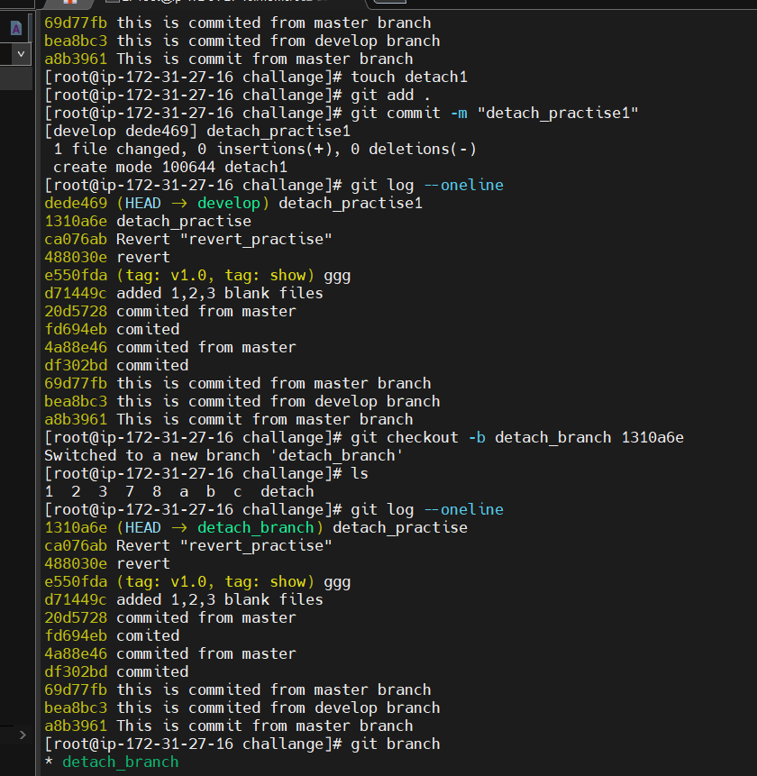
- Git Hooks Challenge
  - Configure a pre-commit hook to reject commits without a message format (e.g., must start with JIRA-XXX).
- I have created a script file in /.git/hooks directory with name commit-msg
- And added the script then whenever any commit done without JIRA ticket number it unable to commit and gives error.
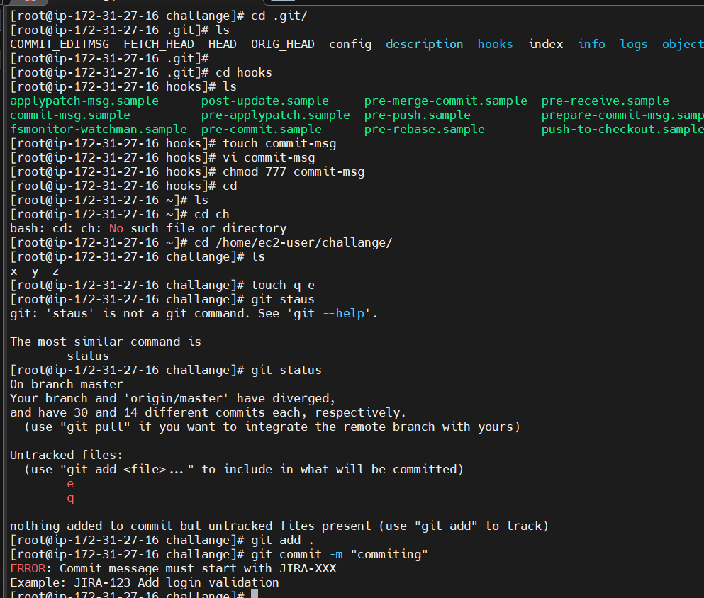
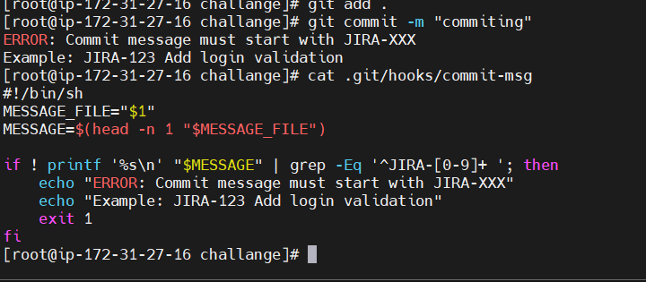

- Squash Merge vs Rebase Merge
  - Show the difference between squash merge and rebase merge with evidence.
- I used ($ git merge –squash <branch name> from develop branch for whatever committed in branch master it will copy in develop branch without committing in stagging are then from there can do commit all file in single commit id and single commit message.
- Git rebase will take all commits history in linear in details it will give clean tree for commie history from that brach.

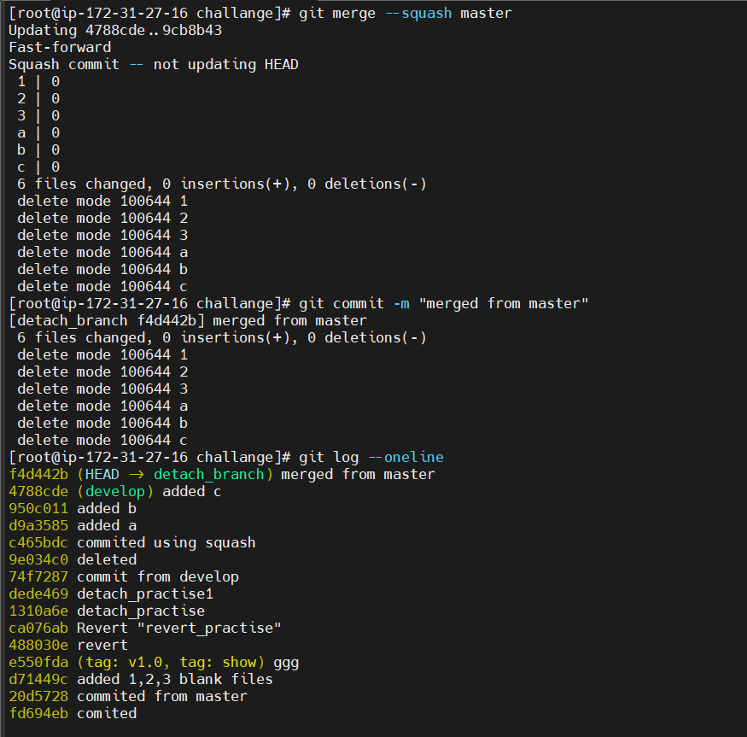

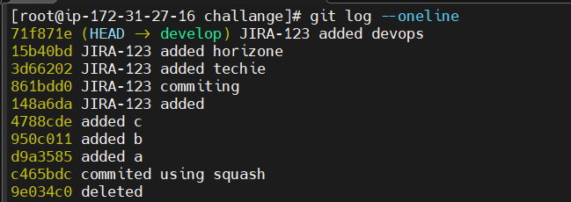
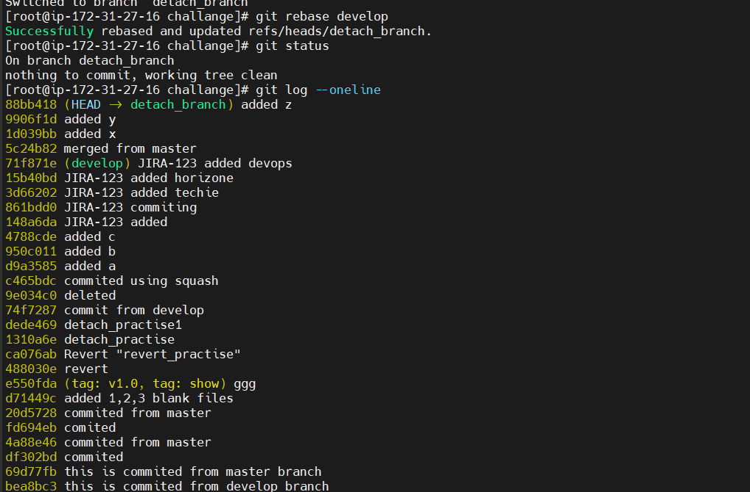

- Fork & Pull Request Workflow
  - Fork a repo, make a change, and submit a pull request to the original repo.
- I searched a repo and clock on fork on up right corner and all the repo is copied in my account
- I have forked a repo from one user and make changes in it and raised the pull request fir it once contributor will accept pull request I will completd and close the request
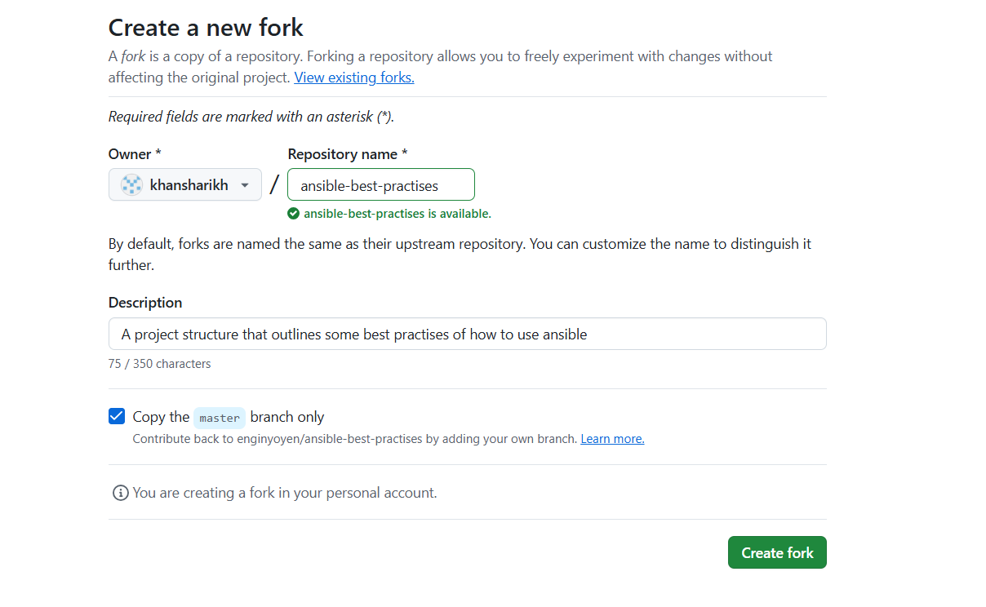
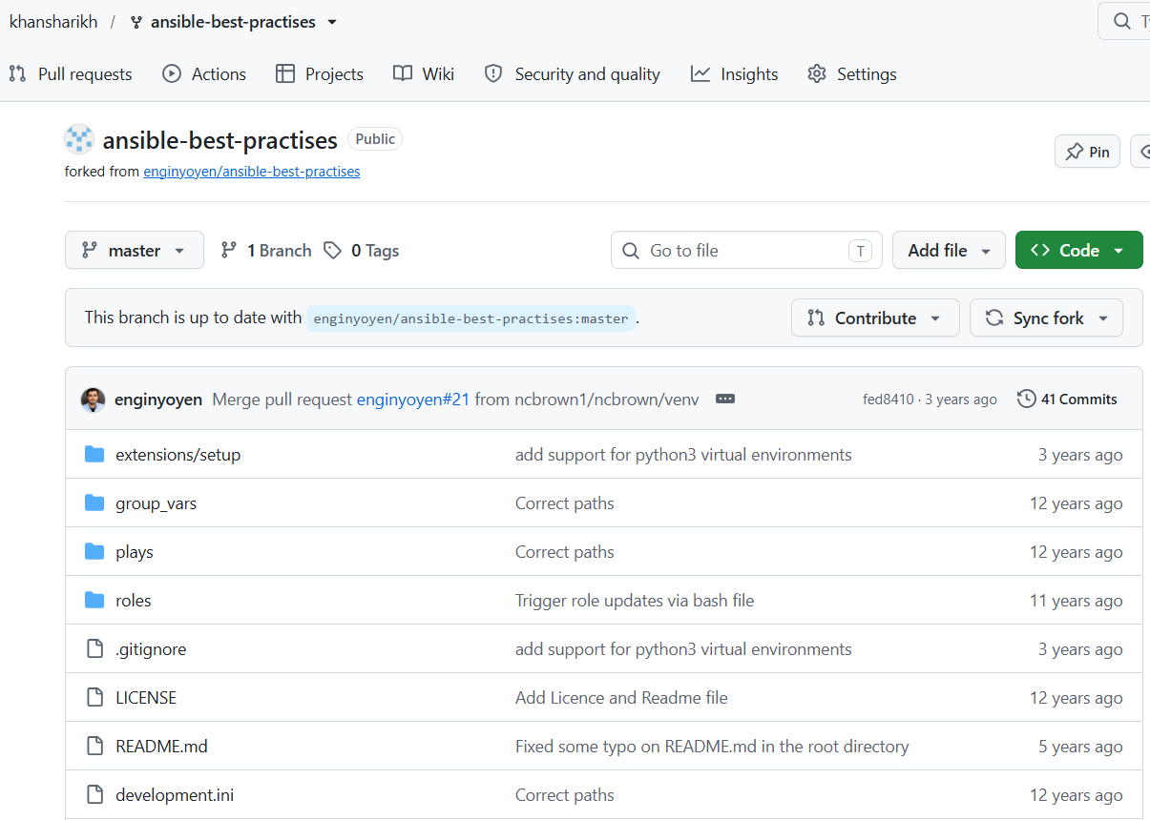
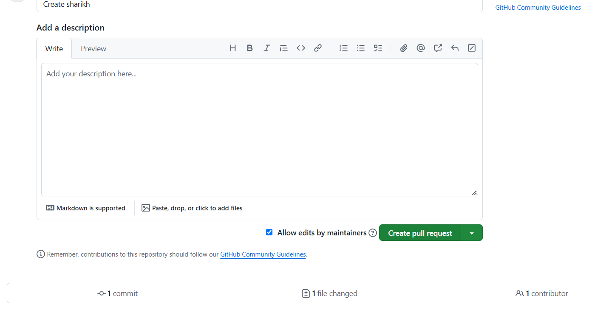
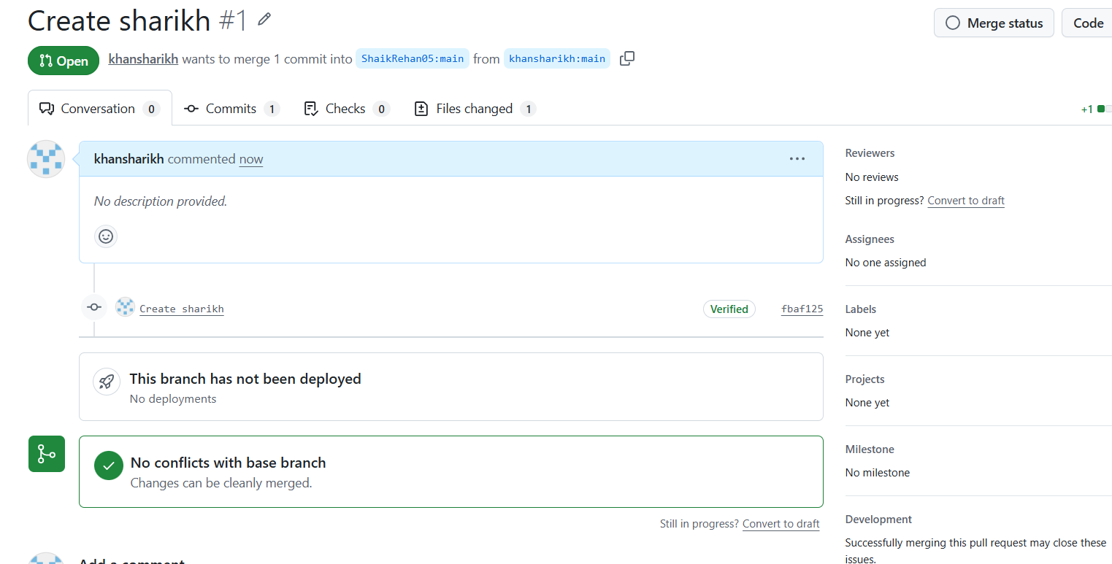
- Recover Lost Commit
  - Commit something, reset hard, and then recover it using git reflog.
- I have added and commieted a filee with name my.txt then I used
- ( $ git reset –hard head~2 ) :- it will deleted the last commit and head towards the second last commit.
- Afte I used ($ git reflog) it will show all committed including missed or deleted.
- After that I found the commit id of my.txt files commit then I did forced reset to that id again and my data and commit history is back.
